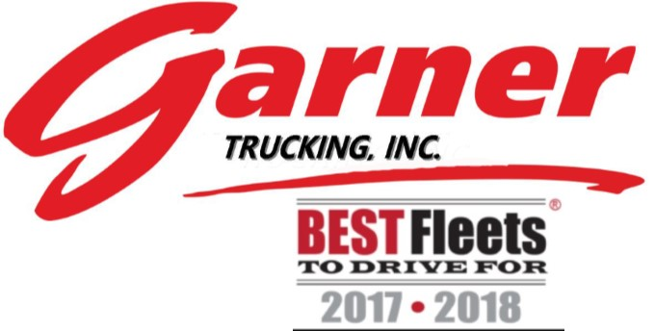

Staff Contact Information
Administration Hours
Office Monday-Friday 08:00am-05:00pm
President/CEO: Sherri Garner Brumbaugh 419-422-5742
Sales & Marketing: Ed McKinley 419-306-0120
Human Resources: Barbara Zimmerman 419-427-3931
HR Assistant: Audrey Wingate 419-427-3942
Safety Manager: Emma Gelacek 419-427-3928
Cell: 419-304-6987

Marketing/Safety Assistant: Jenny Schaub 419-427-3938
Recruiting/Retention: Makenzie Melton 419-427-3939
Cell: 419-889-0504

IT: Jeff Frantz 419-421-4943
Finance Director: Mike Palte 419-427-3940
Finance Supervisor: Brian Loch 419-421-4942
Accounting Assistant: Julie Dean 419-427-3932
Payroll Specialist: Brad Lucius 419-427-3929

Operations Hours
Office Sunday-Friday 10:00pm-07:00pm
Weekly on call 07:00pm-10:00pm
Weekend on call Friday-Sunday 10:00pm-10:00pm
Operations Director: Tim Chrulski 419-427-3930
Driver’s Number to dispatch 419-422-7267
Driver Manager: Shawn Piper
Driver Manager: Troy McLaughlin
Load Coordinator: Rex Fletcher
Load Coordinator: Matt Ritchie
Customer Service Manager: Kim Fredritz

Shop Hours
Monday-Friday 06:30am-5:30pm
Saturday 08:00am-1:00pm
Maintenance Director: James Husted 419-427-3933
Drivers number to call shop: 419-425-1550
Technicians:
Ben Brumbaugh Tom Boedecker
Brent Palmer Jon Foust
Joshua Davis Justin Romick
Jon Sorrell Ken Durst (Apprentice)

Ron’s/GCM
Monday-Friday 08:00 a.m.-4:30pm
General Manager: Jim Newsome 419-334-4040
Accounting Supervisor: Cheryl Thompson 419-427-3927
Office Assistant: Charlotte Freeman 419-334-4040
Technicians:
David (Harley) Busack Dale Karr
Matt Meacham Caleb Shearn
Dale Wisniewski Jeremiah Aldred

Commonly Used/Needed Garner Email Addresses

Accounting: Bolscan@garnertrucking.com
- Used to submit the following:
  - BOL’s
  - Cash Receipts
  - Scale Tickets
  - Payroll Sheets
  - Anything else that goes to payroll

Human Resources(HR)/Safety: garner@garnertrucking.com
- Used to submit the following:
  - Return to Work Slips
  - FMLA Paperwork
  - First Report of Injury
  - Accident Pictures
  - DOT Inspections
  - Traffic Tickets
  - Updated CDL Licenses
  - Anything else that goes to HR or safety

Operations: dispatch@garnertrucking.com
- Used to submit the following:
  - OS&D Pictures
  - Anything else that goes to operations

Maintenance: garnershop@garnertrucking.com

Driver Advisory Board Information
Email: DAB@garnertrucking.com - goes to the current chairman
John Toupalik – Advisory Board Chairman
419-722-2507
toupalik@aol.com

Scott Brown
847-650-5118
mollshan@aol.com

Shawnta Dix
937-232-3919
Shawnta_Dix@yahoo.com

Robert Downing
567-204-2958
Angelasue104@yahoo.com

Gesse Liberato
419-274-9374
gesseleslie@gmail.com

Kevin Taylor
419-322-8671
kmtay@gmail.com

Brian Wildman
440-454-2515
Brianpwr1@aol.com

Recommended Items for Your Assigned Tractor

- Hammer 2-4lbs
- Crow Bar
- Heavy Duty Vice Grips
- Crescent Wrench
- Multi-Tool (Gerber or Snips)
- Screwdriver (Phillips & Flathead)
- Pliers
- Flashlight
- Zip Ties
- Broom
- Work Gloves (2 pair)
- Salt or Kitty Litter (Winter Months)
- CB Radio
- Road Atlas
- Clothes – to include warm clothing such as coat, hat, gloves (for 5-6 days)
- Notebook Paper & Pens
- Non-perishable Food & Water
- Bedding – to include warm blankets
- Toiletries
- Towels
- Cooler
- Medication(s) – in original labeled bottles
- Cell Phone & Charger
- Blue Tooth Headset
- Sunglasses
- Tire Gauge
- Duct Tape
- Emergency Response Guide Book (If you have the HAZMAT Endorsement)
- Driver’s Manual

